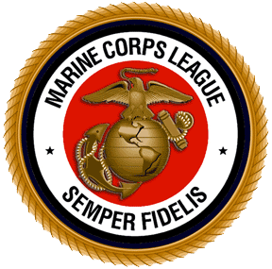
Marine Corps League
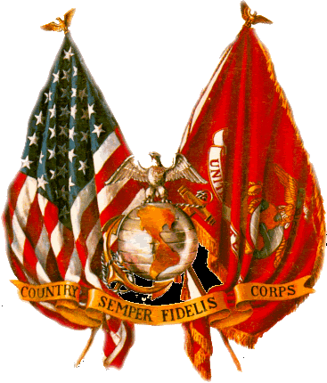

Cherry Point Detachment #1067

invites your business or organization
to advertise in our 2015 Convention Program Booklet,
Commemorating the 45th Anniversary of the


June12-June 14

Outside
Back Cover
$15000

Inside Cover $12500

Full Page $10000

½ Page
Horizontal
$5000

½ Page
Vertical $5000

¼ Page
$3000

Centerfold $20000

1/8 Page
$2000

Patron
Business Card-Size
$500

Complimentary copies of the Program will be distributed to Attendees, Advertisers and at functions throughout the year!

- Complete order form
- Camera-ready ad layout
- Check payable to:

Cherry Point Det. # 1067

- Mail to:
Cherry Point Det. #1067
C/O: Scott Shermeyer
208 Hollywood Blvd
Havelock, NC 28532

Deadline: all orders must be received no later than 15 May, 2015

More Info or Submit Online Order:
Call: 252-515-1175
Click: http://convention.mclcp.org
Email: convention@mclcp.org

Name
Company
Street Address
City, State, Zip
Telephone |  |  |  |  | Cell #
Email address
Please Check Mark next to the Size of your Ad:
 | Outside back cover $150^{.00} |  |  | Half page – vertical $50^{.00}
 | Inside cover $125^{.00} |  |  | Quarter page $30^{.00}
 | Full page $100^{.00} |  |  | Eighth page $20^{.00}
 | Half page – horizontal $50^{.00} |  |  | Business card/Patron $5^{.00}

