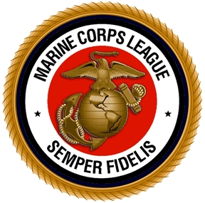
Name:
Street:
City: State: Zip:
Phone: Date of Birth: e-mail:
Type of Application: Associate Regular Dual
Have you ever been convicted of a felony? No Yes If Yes is checked, I agree to waive my rights under the Privacy Act and disclose the nature of the felony conviction for consideration of membership in the Marine Corps League.
Regular Membership
I hereby apply for Regular Membership in the Cherry Point Detachment, Marine Corps League
I have enclosed $30 for one (1) year’s membership
(Includes free subscription to “Semper Fi” –
The Magazine of the Marine Corps League)
I have enclosed a valid copy of my DD-214
Date of Enlistment/Commissioning:
Date of Discharge/Separation/Retirement: I am currently still on Active Duty

I hereby certify that I am currently serving or have served honorably in the United States Marine Corps, "ON ACTIVE DUTY," for not less than ninety (90) days and earned the Eagle, Globe and Anchor;* or have served or am currently serving in the United States Marine Corps Reserve and have earned no less than ninety (90) Reserve Retirement Credit Points; or that I have served or am currently serving as a U.S. Navy Corpsmen who has trained with Marine FMF Units in excess of ninety (90) days and earned the Marine Corps Device (clasp) or the Warfare Device worn on the service ribbon, authorized for FMF Corpsmen; or have served or are currently serving as a U.S. Navy Chaplain and have earned the FMF Badge serving with Marines; if discharged, I am in receipt of a DD Form 214 or a Certificate of Discharge indicating "Honorable Service." ("Honorable Service" will be defined by the last DD Form 214 or Certificate of Discharge that the applicant received). General Discharge under Honorable Conditions is acceptable. By signature of this application, I hereby agree to provide proof of honorable service/discharge upon request. I hereby authorize the National Executive Director, Marine Corps League to obtain an un-redacted copy of my latest DD Form 214 from the Marine Corps custodian of Official Military Personnel Files (OMPF), and/or verification of honorable service if deemed necessary to verify my eligibility for regular membership in the Marine Corps League. I understand the DD Form 214 may contain information such as military awards, training, and character of service.
(*Korean War Era Marines See National Bylaws, Article 6, Section 600)

I, , in the presence of Almighty God and the members of the Marine Corps League here assembled, do solemnly swear or affirm that I will uphold and defend the Constitution and Laws of the United States of America and of the Marine Corps League. I will never knowingly deceive or defraud the League to the value of anything. I will never knowingly wrong or injure or permit any member of any member’s family to be wronged or injured if to prevent the same is within my power. I will never propose for membership one known to me to be unqualified or unworthy to become a member of the League. I further promise to govern my conduct in the League’s affairs and in my personal life in a manner becoming a decent and honorable person and I will never knowingly discredit the League, so help me, God.
_________________________________ ____________________________________
Sponsor (If Applicable) Applicant’s Signature

Associate Membership Only:
I hereby apply for Associate Membership in Cherry Point Detachment, Marine Corps League
I have enclosed $30 for one (1) year’s membership.
(Includes free subscription to “Semper Fi – The Magazine of the Marine Corps League”)

I, , in the presence of Almighty God and the members of the Marine Corps League here assembled, being fully aware that as an Associate Member, I will not be permitted to hold an elective office or to vote on Marine Corps League policy, a membership application, or an election of officers, do solemnly swear or affirm that I will uphold and defend the Constitution and Laws of the United States of America and of the Marine Corps League. I will never knowingly wrong, deceive or defraud the League as to the value of anything. I will never knowingly wrong or injure or permit any member of any member’s family to be wronged or injured if to prevent the same is within my power. I will never propose for membership one known to me to be unqualified or unworthy to become a member of the League. I further promise to govern my conduct in the League’s affairs and in my personal life in a manner becoming a decent and honorable person and will never knowingly bring discredit to the League, so help me, God.
_________________________________ ____________________________________
Sponsor (If Applicable) Applicant’s Signature
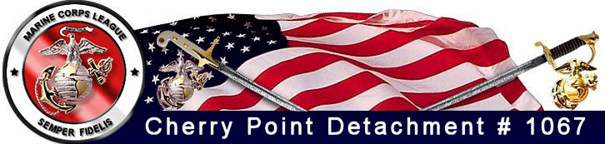
Duty Phone: 252-515-1175 www.mclcp.org info@mclcp.org

- Please send completed form with check or money order, in the amount of $30.00, payable to “Cherry Point Det. #1067, MCL” to:
Cherry Point Det. # 1067
C/O Scott Shermeyer
208 Hollywood Blvd
Havelock, NC 28532-2321

- Or bring to any detachment meeting –
- Or give to a current member

NOTE: If you are a veteran applying for “Regular Membership”, please also include a copy of your DD-214 or Certificate of Discharge.

Meeting Place: MCAS Cherry Point MILLER’S LANDING - Consolidated Club
When: 3rd Thursday of each month, 1900 hrs

Miller’s Landing is located next to the “Sound of Freedom” Golf Course at the end of Jackson Drive aboard MCAS Cherry Point.

Thank you for applying for membership in the Marine Corps League. Your application will be reviewed at first regular meeting after receipt. We request you attend at least one regular meeting so you may be officially sworn into the Detachment & introduced to other members.

WHAT DOES THE MARINE CORPS LEAGUE DO?
Joins together Marines and FMF Corpsmen who have served or are serving in and with the United States Marine Corps faithfully and are joined together by certain high principles and for worthy purposes which are:
- To preserve the traditions and to promote the interests of the United States Marine Corps.
- To band together those who are now serving in the United States Marine Corps or as FMF Corpsmen and those who have been honorably discharged from that service, in fellowship that they may more effectively promote the ideals of American freedom and democracy.
- To fit members for the duties of citizenship and to encourage them to serve as ably as citizens as they have served the nation.
- To hold the history and memory of all men and women who have given their lives for our nation.
- To foster love for the principles which they have supported by blood and valor since the founding of the Republic.
- To maintain true allegiance to American Institutions.
- To create a bond of comradeship between those in service and those who have returned to civilian life.
- To aid voluntarily and to render assistance to all Marines, and FMF Corpsmen and to their widows and orphans.
- To perpetuate the history of the United States Marine Corps and, by fitting acts, to observe the anniversaries of historical occasions of particular interest to Marine

